Feedbacks to Initial Staging Website

Link to the website:

<https://staging.aaci-library.org/legislation-tracker>

# Viewer’s End:

## Banner and Navbar:

We need to think more on this. Jaren likes the current idea where it is incorporated into the PPRL. But it is mildly confusing when Home doesn’t go to the Home page of the legislation tracker, and the Browse topic is for PPRL and not for the tracker. It need more consideration here.

## Main Page:

* Feels more consistent if all the [Overviews] and [See full details] stick to the bottom of the card, regardless of how many texts are there
* (Mobile) Can’t open nav bar

## Overview Page:

* (Desktop) It would be better to be less wide, maybe try covering ¾ of the screen?
* And it would be better if the user won’t exit the page while clicking inside the overview contents
* When scrolling up, the top of the overview banner gets covered by the navigation bar. It might be good to superimpose the overview box on top of the page.

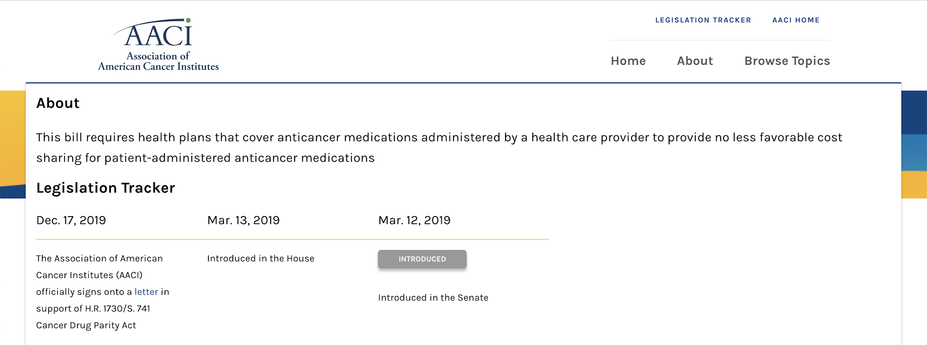

## Full Detail Page:

* It would be better if all the dates are consistently displayed in one line
* The font size is a bit too large, maybe try changing it to a smaller size.
* *(After we review the updated font size)* We would want to change the highlight tags (caps for the content, maybe also adjust the font size inside)

# Backend:

* When adding a new tracker field, it would be better if the user can select date instead of entering date manually. Also, it would be nice to allow selecting a month rather than a specific date. (For example, ***March. 2019*** and ***March.03 2019*** should both be valid entry)
* It might be better to put newly updated entries automatically to the top, but also allow user to manually set the order
* We would like a new About page for the legislation tracker. We are still thinking about how to incorporate the new About page to the navbar, and we will update once we have a solid idea.